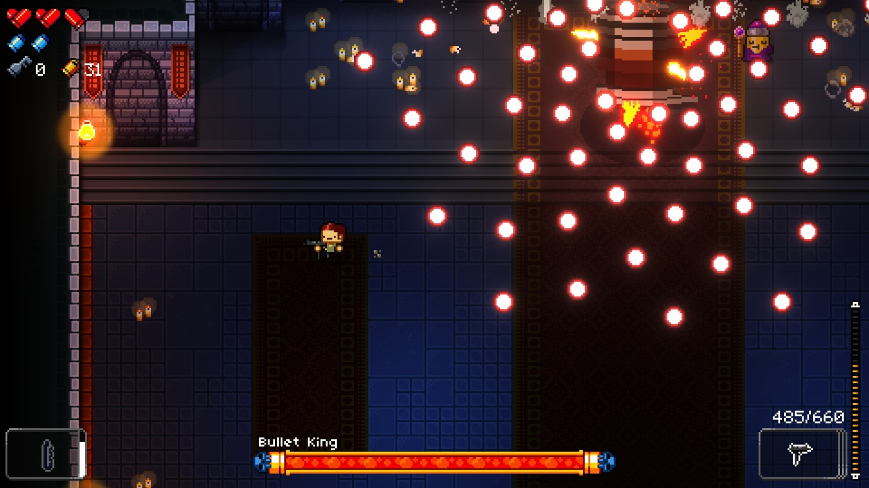

Important elements are put in the corners, minimizing the area covered.

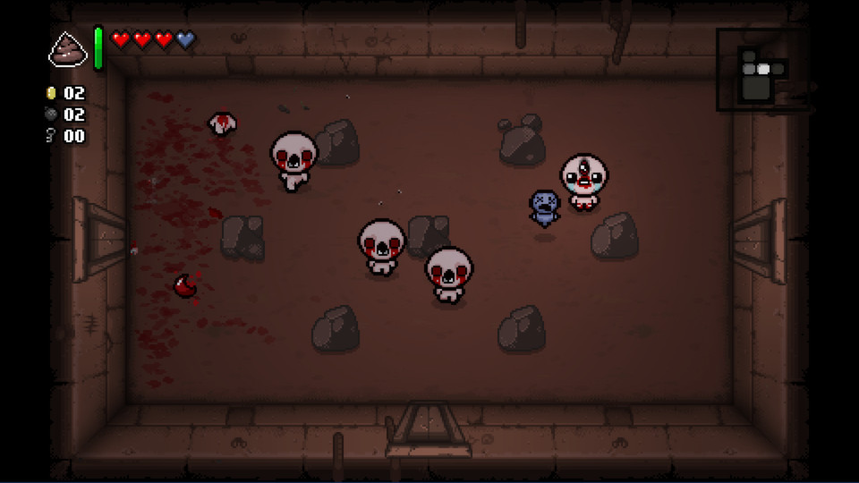

HUD occupies an area that typically isn’t used, the map can be expanded but player stats aren’t shown so the effects of items isn’t always apparent

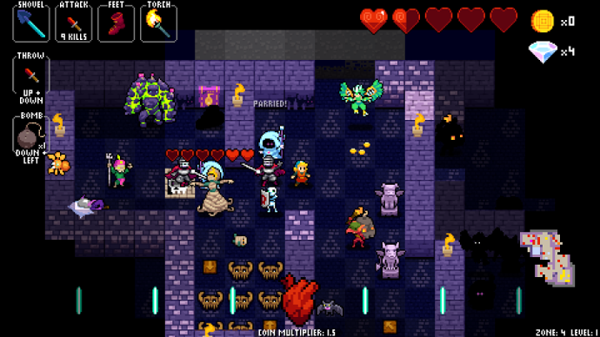

Information is provided but some details like the hearts are too large personally

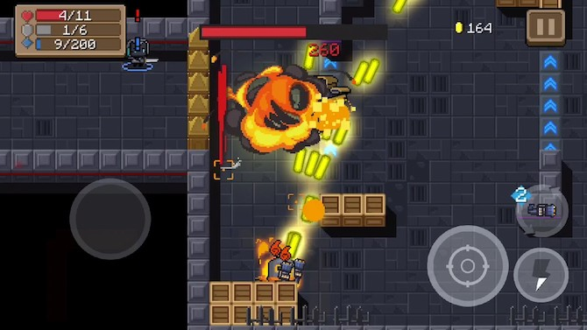

This UI suffer from being designed for touch screens as the buttons must be large so they can be pressed which covers the action

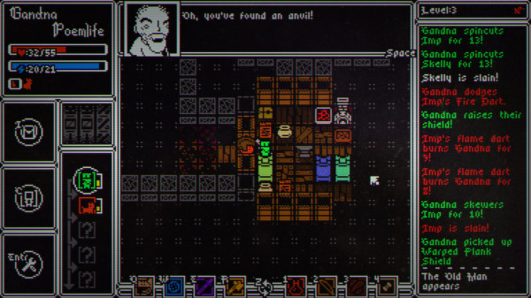

The HUD takes up so much space that it’s hard to see what’s going on

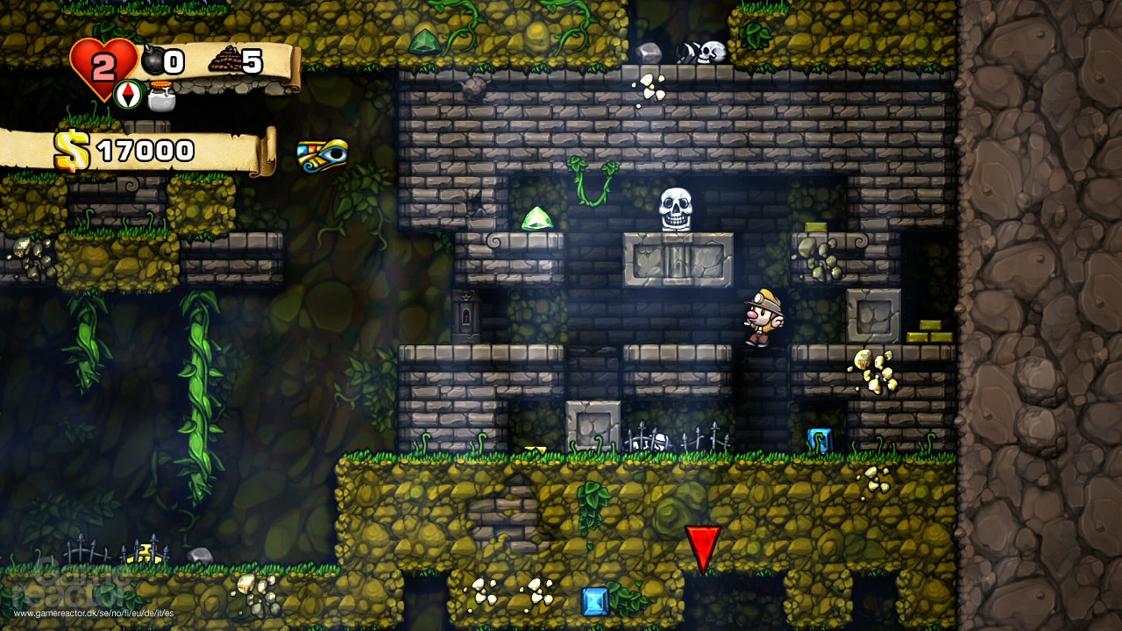HUD all in one corner which is usually fine as the player doesn’t go near it but may obscure traps

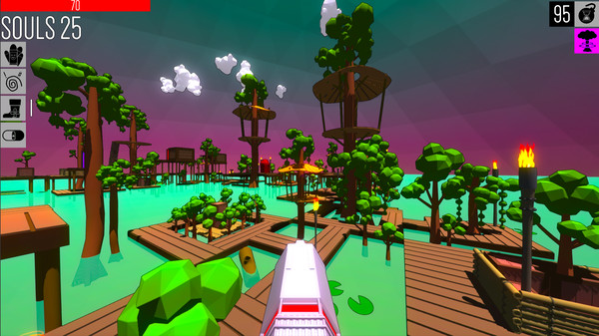

No reticule, Icons don’t block the screen but their purpose is unclear

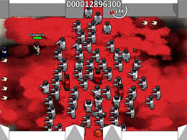

The HUD is quite barren so while all of the screen is visible vital information is hard to find.

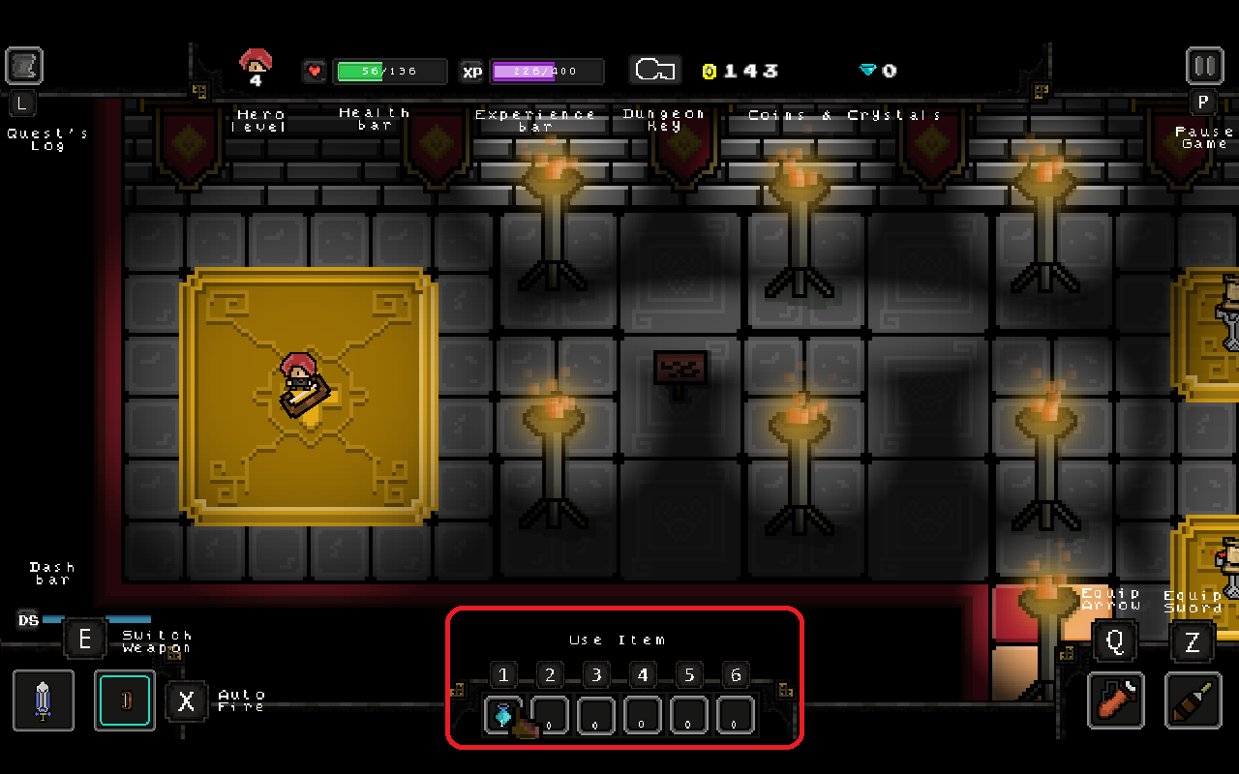

Large amount of info that is possibly superfluous but is spread out enough so it’s not too distracting.

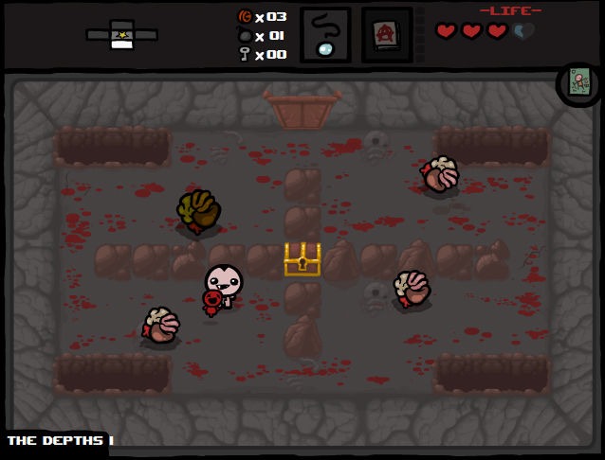

Information is cleanly separated which may slightly squish the game view but info is provided.